password manager app

there is two type of group in this app  
  
1 . access user group   
  
2 . access manager group  
  
  
  
  
  
  
  
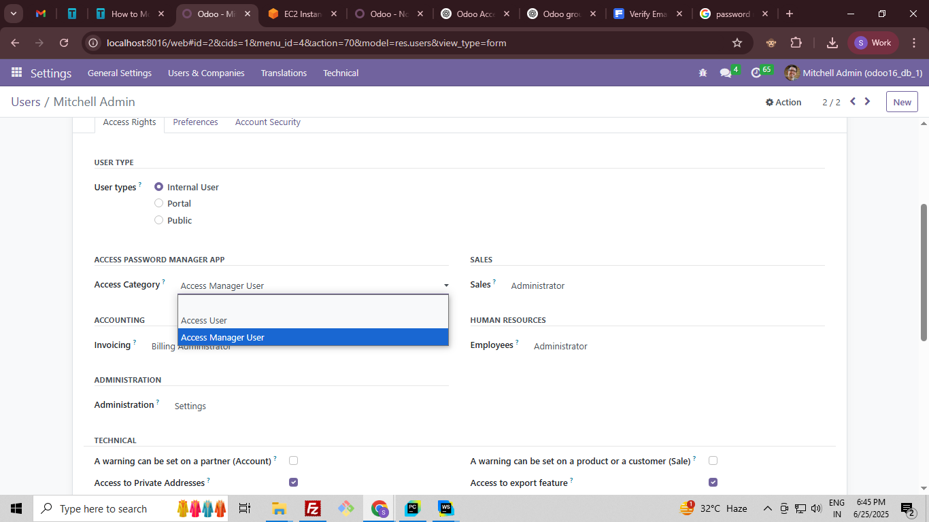

:-- this app access manager level all type access means form create , read , write , delete.  
  
  
  
  
  
